**Project Planning Phase**

**Project Planning Template (Product Backlog, Sprint Planning, Stories, Story points)**

|  |  |
| --- | --- |
| Date | 6 Nov 2022 |
| Team ID | PNT2022TMID48683 |
| Project Name | Early Detection of Chronic Kidney Disease using Machine Learning |
| Maximum Marks | 8 Marks |

**Product Backlog, Sprint Schedule, and Estimation (4 Marks)**

Use the below template to create product backlog and sprint schedule

| **Sprint** | **Functional Requirement (Epic)** | **User Story Number** | **User Story / Task** | **Story Points** | **Priority** | **Team Members** |
| --- | --- | --- | --- | --- | --- | --- |
| Sprint-1 | Registration | USN-1 | User can sign in to our web application by using google account | 12.5 | High | Mohamed Ibrahim, Mohamed Asif, Prabhu, Kamalesh |
| Sprint-1 |  | USN-2 | Users are considered to fill the google form for further authentication | 12.5 | Medium | Mohamed Ibrahim, Mohamed Asif, Prabhu, Kamalesh |
| Sprint-1 |  | USN-3 | User log in data is stored and surveillance by google firebase authentication service | 12.5 | High | Mohamed Ibrahim, Mohamed Asif, Prabhu, Kamalesh |
| Sprint-1 | Login | USN-4 | User now successfully registered using google authentication service | 12.5 | High | Mohamed Ibrahim, Mohamed Asif, Prabhu, Kamalesh |
| Sprint-2 | Dashboard | USN-5 | Now user is preferred to enter the medical details to analyse their disease severity or whether they have that disease | 12 | High | Mohamed Ibrahim, Mohamed Asif, Prabhu, Kamalesh |
| Sprint-3 | Dashboard | USN-6 | There are three values which should be given in float or numerically | 11.8 | High | Mohamed Ibrahim, Mohamed Asif, Prabhu, Kamalesh |
| Sprint-3 | Dashboard | USN-7 | There are some other valuers which are fulfilled by alpha values whether they have or not (yes or no questions) | 12 | High | Mohamed Ibrahim, Mohamed Asif, Prabhu, Kamalesh |
| Sprint-4 | Dashboard | USN-8 | After fulfilment of user medical values the prediction of disease is analysed by machine learning model that present in the IBM Watson machine learning platform | 12.5 | High | Mohamed Ibrahim, Mohamed Asif, Prabhu, Kamalesh |

**Project Tracker, Velocity & Burndown Chart: (4 Marks)**

| **Sprint** | **Total Story Points** | **Duration** | **Sprint Start Date** | **Sprint End Date (Planned)** | **Story Points Completed (as on Planned End Date)** | **Sprint Release Date (Actual)** |
| --- | --- | --- | --- | --- | --- | --- |
| Sprint-1 | 12.5 | 4 Days | 20 Oct 2022 | 24 Oct 2022 | 12.5 | 24 Oct 2022 |
| Sprint-2 | 12.5 | 4 Days | 24 Oct 2022 | 28 Oct 2022 | 12 | 29 Oct 2022 |
| Sprint-3 | 12.5 | 3 Days | 28 Oct 2022 | 2 Nov 2022 | 11.9 | 2 Nov 2022 |
| Sprint-4 | 12.5 | 4 Days | 2 Nov 2022 | 6 Nov 2022 | 12.5 | 5 Nov 2022 |

**Velocity:**

Imagine we have a 10-day sprint duration, and the velocity of the team is 20 (points per sprint). Let’s calculate the team’s average velocity (AV) per iteration unit (story points per day)

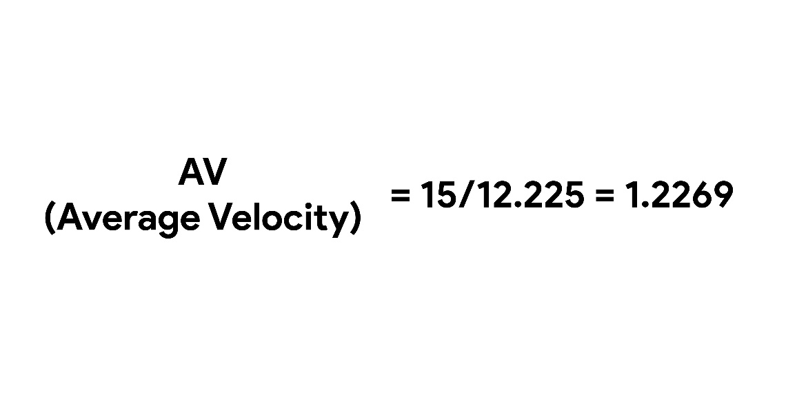

**Burndown Chart:**

A burn down chart is a graphical representation of work left to do versus time. It is often used in agile[software development](https://www.visual-paradigm.com/scrum/what-is-agile-software-development/) methodologies such as [Scrum](https://www.visual-paradigm.com/scrum/scrum-in-3-minutes/). However, burn down charts can be applied to any project containing measurable progress over time.

